Final Paper
The Effects of Screen Time on Development and Learning
Rubi Perez
October 10, 2023
EDFR 6300 Research Methods in Education
University of Texas Rio Grande Valley

Abstract
The aim of this literature review is to investigate the relationship between screen time and development and learning for students in preschool. There were four peered reviewed articles chosen that were able to answer the four research questions guiding this investigation. The four research questions focused on the relationship between screen time and cognitive development, language development, sleeping patterns, and emotional development. All the articles conducted a study with preschool students of various areas including Canada, Finland, Italy, and Lithunia (Europe.) After analyzing the results for all four studies, the conclusion is that screen time on preschoolers has a negative effect on their cognitive development, language development, sleeping patters, and emotional development.

Keywords: Screen time, cognitive development, language development, emotional development, sleeping patterns.

Introduction
Purpose and Problem
The purpose of the literature review is to investigate the relationship between screen time and development and learning in preschool students. The reason why I decided to focus on preschool students is because early childhood education sets the foundation for the upcoming years of learning. This literature review will be guided by four questions that will investigate screen time on specific elements of development and learning. Each of the articles chosen for this review will include a study that helps answer each of the research questions.
Background
Technology surrounds us and is used in many aspects of our everyday lives. Children are now in a technology revolution that enables to them to be more technology savvy. In addition, we use technology as a source of entertainment by engaging in different forms of media such as televisions, computers, phones, and video games. In an era where children are so drawn to technology, it is inevitable for children to be exposed to it. It is because of this that I’d like to dive deep into the effects that screen time has on children development and learning. As an educator, I’d like to know how I can use technology wisely for students to benefit from it and not be on the way of their learning and development.
The reason why I investigated the preschool population is because my area of expertise lies within elementary students. In addition, I believe that preschool sets a foundation for student academics. If educators set a great foundation for students from the beginning of their academics, they will be more successful as they navigate through different levels of their academics.
Moreover, early childhood resonated with me after watching a talk from Diane Ravitch, who served as the U.S. Assistant Secretary of Education and was an activist for public schools and “no child left behind” movement. She mentioned that the most beneficial area of focus lies within early education. Additionally, I found an article that states argues that early childhood is considered a critical period. “One of the most enduring arguments advanced in support of improving and expanding early childhood education programs is that the early childhood years constitute a critical period in human development.”

Research Questions
This study will be guided by the following research questions:
- How does screen time affect cognitive development?
- How does screen time affect language development?
- How does screen time affect sleep patterns?
- How does screen time affect emotional development?

Methods
Information was gathered from different peer reviewed articles that were found in ERIC and Google Scholar. The articles were chosen based on their relativity to the research questions. Abstracts were read for various articles to identify the relationship between variables associated with the research questions. There were four studies that were selected based on their research methods and results that were found very relatable to the research. Below you will a breakdown of each article by identifying the articles experimental methods and results.

Screen Time on Cognitive Development
This study was conducted to find the relationship between screen time and cognitive development in preschoolers. Researchers identified the amount of daily screen time the toddlers were exposed to. Then compared the amount of screen time to cognitive development tests. Cognitive development was identified as expressive vocabulary and working memory which were identified using an Early Years Toolbox.
Methods
This study was conducted as a cross-sectional study because it collected data from different individuals at a single point in time. Participants were 97 preschoolers from the age of 36 to 60 months in Alberta and Ontario, Canada. The screen time was identified as watching television, videos or DVDs, or playing video or computer games on a television, computer or portable device. The amount of screen time was assessed by using a parental questionnaire. Expressive vocabulary was assessed with the task “expressive Vocabulary” and working memory was assessed with the task “Mr. Ant.” Each task had instructions, practice, feedback and scoring. Statistical analyses were performed using SPSS version 26.0. Researchers identified comparisons for TV time and cognitive development, video game time and cognitive development, overall screen time and cognitive development, and recommended amount of screen time and cognitive development. Null models were used to find correlation with expressive vocabulary and working memory.
Results
None of the screen time variables were associated with expressive vocabulary. Regarding working memory, there were no significant associations for TV time or VG time. However, higher total screen time was associated with lower odds of having better working memory (OR=0.52; 95%CI:0.31, 0.88). Compared with nonadherence, adherence to the screen time recommendation was associated with higher odds of having better working memory (OR=3.48; 95%CI:1.06, 11.47).

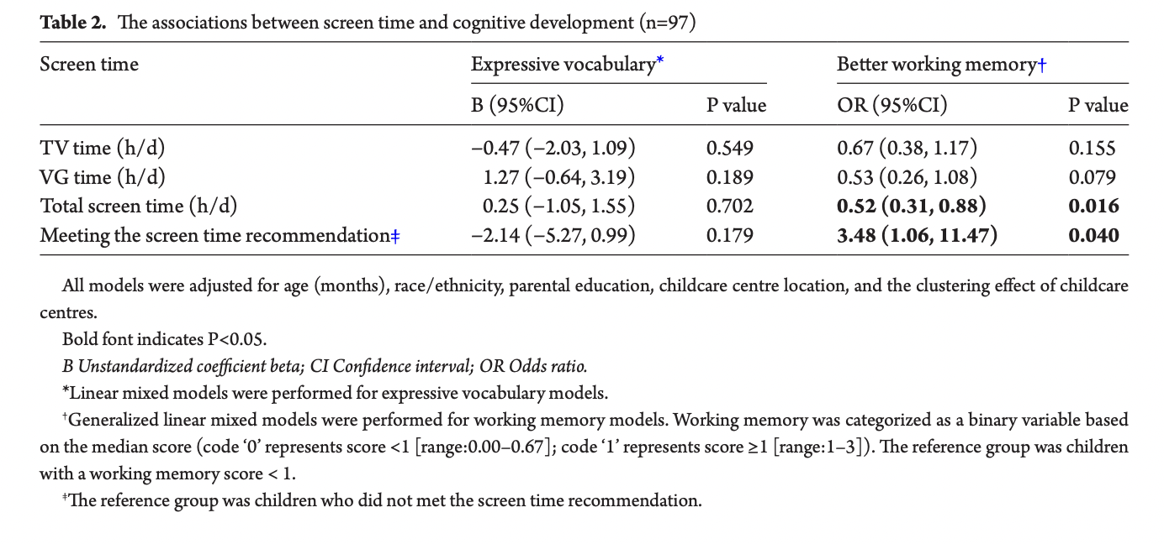
Working memory has often been connected or related to intelligence, information processing, executive function, comprehension, problem solving, and learning in people ranging from infancy to old age, and in all sorts of animals (Cowan 2013.) Based on this study we can conclude that higher amounts of screen time have a negative effect on cognitive development based on its effect on working memory.

Screen Time on Language Development
This study aimed to investigate the relationship between screen time of preschool children and their mothers to the children’s language development. Researchers identified the amount of screen time children, and their mothers by questionnaires. Then, language development was measured by lexical, phonological, morphological, repetitive, and general abilities using validated tests.
Methods
Participants were 164 monolingual Finnish-speaking children aged 2.5 to 4.1 and their mothers. Mothers completed “The Screen Time Questionnaire” to evaluate how much time the children and their mothers spent on screen time. Screen time was defined as any time spent on TV, and or watching or using mobile devices, computers, laptops, and game consoles. Information on expressive lexical skills was gathered using the vocabulary section of the Finnish version of the MacArthur Communicative Development Inventories III. The Finnish Phonology test and Finnish Morphology test were used to test components of language structures. The raw points were converted into percentile values and then later used in the study. The receptive part of the Reynell Developmental Language Scalles III and the total score of the Finnish version of the MacArthur Communicative Development Inventories III were used to measure the children’s expressive language ability. For the RDLS III, standard scores were used (mean value of the norming group: 100 standard points; ±1 SD = 15 standard points). The screen time of the children and the mothers on a weekday and on a day off were first transformed into daily averages using the formula: [5 × screen time on a weekday + 2 × screen time on a day off] ÷ 7. Pearson’s correlations and partial correlations (controlled for age) were used to examine the associations between the amount of daily screen time of the children (alone and with a parent) and their mothers and the children’s language skills. IBM SPSS statistics, version 26 for Windows was used to analyze the data. The level of significance was 0.05 in all the analyses.

Results
The more the children used screen time alone, or the greater the amount of the mothers’ screen time, the weaker the children’s lexical and general language abilities when the children’s age, maternal education level, and birth order were controlled for. negative links to the children’s lexical and general language abilities when the amount of their screen time alone and the amount of the mothers’ screen time were simultaneously included in the regression model. As seen in the table provided by the study, values allow to conclude that screen time has a negative effect on language development.
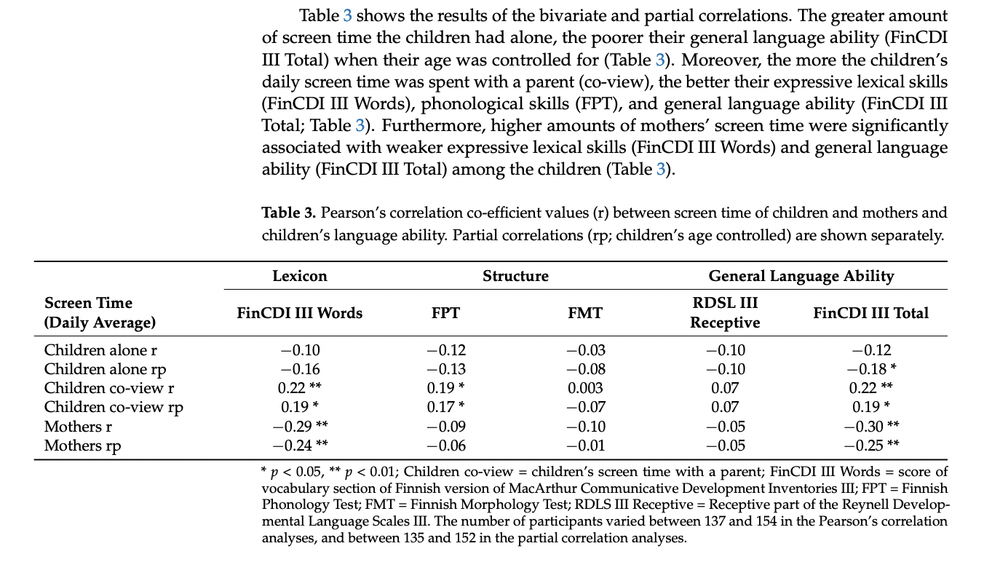

Screen Time on Emotional Development

This 4-year longitudinal study aimed to evaluate the hypothesis that the use of digital devices as smartphones and tablets at 4 years of age is related to later dysregulation symptoms and to lower academic achievements both at 6 and 8 years of age. Screen time was evaluated by questionnaires completed by mothers. Children’s teachers were administered the Teachers Report Form including the competence part to evaluate academic achievements and possible dysregulation symptoms of their students.
Methods
The participants of the longitudinal study were selected from a larger community-based study that was conducted to examine the risk and prevention factors associated with psychopathology in young children and their mothers. Participants were narrowed down to 365 children ages 4 and their mothers. The present study reports data and results of two assessment waves after the T₀ of the original study (children aged 4 years): T₁ (children aged 6 years), T₂ (children aged 8 years). At T₁ and T₂: children’s teachers completed the Teachers Report Form including the competence part to evaluate academic achievements and possible dysregulation symptoms of their students.
Results
Bivariate Pearson correlation analyses were performed on the whole sample to verify possible associations between all variables. Children’s sex was positively correlated (boys showed higher scores) with screen time and dysregulation, whereas it negatively correlated with mathematics grades. Children’s age was positively correlated with screen time, dysregulation and academic performance, and negatively with maternal scaffolding; screen time was positively correlated with mothers’ PIDA scores, and negatively dysregulation and academic performance; maternal scaffolding was negatively correlated with dysregulation but positively with academic performance; dysregulation was negatively correlated with academic performance; and mathematics was positively correlated with literacy scores.
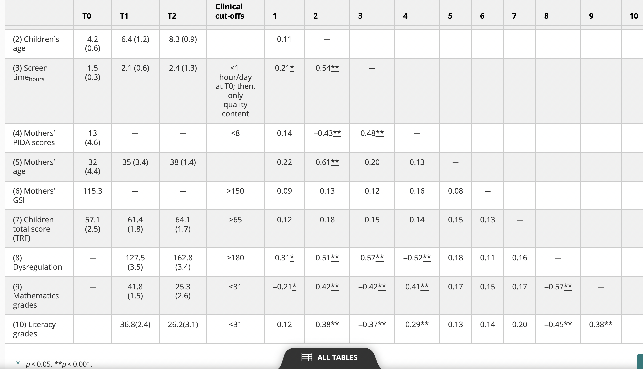
Notably, children’s screen time increased over time and dysregulation significantly increased from T1 to T2. In addition, math and literacy grades dropped over time. This allows us to see that screen time negatively affects emotional development.

Screen Time on Sleeping Patterns

This study aimed to investigate the relationship between toddlers’ and preschooler’s sleep problems, screen-based media use, sleep regime and the role of child emotional reactivity in this this relationship. Questionnaires were given to investigate the child’s sleep regime and screen time. Children’s sleep problems and emotional reactively were assessed using a Lithuanian version of the Child Behavior Checklist. Analysis was created using SPSS 23.0 and SPSS Amos 19.

Methods
The study included 754 children (52% girls), aged 2-5 years old. The average children’s age was 44.9 months and 94% of children were attending pre-school education services (kindergarten.) This research was part of an extensive longitudinal national study “electronic Media Use and Young Children’s Health” which was conducted in the year 2017-2018. Parents and toddlers were living in various regions of Lithunia and invited to take part of the research through pre-school education institutions, health care specialist and social media. Children’s sleep problems and emotional reactivity were assessed using a Lithuanian version of the Child Behavior Checklist. It is a 100-item parent-report measure designed to record the problem behaviors of preschoolers. Each item describes a specific behavior, whereas a parent is asked to rate its frequency on a three-point Likert type scale (0–not true; 1–somewhat or sometimes true; 2–very true or often true) based on the preceding 2 months. The reliability of Sleep Problems scale (7 items, Cronbach’s alpha = 0.65) and Emotionally Reactive scale (9 items, Cronbach’s alpha = 0.74) for data of this research is sufficient and reliable. A child’s screen time, sleep regime and sleep duration were measured using the parent-report questionnaire.

Results
Sleep problems were positively associated with emotional reactivity, sleep onset duration, and a lack of sleep regime, as well as were negatively related to overall sleep duration. No significant associations between screen time and sleep problems were found, although screen time was positively associated with sleep regime and emotional reactivity. Significant differences were found for mean scores of sleep problems and screen time, e.g., children, who had any of screen-based devices in their room tended to have more sleep problems and used the screen longer. In addition, the cross-tabulation analysis showed that having a screen-based device in the child’s bedroom was not significantly associated with sleep regime. Despite having different variables included in this study, we can see that screen time negatively affects sleeping patterns.
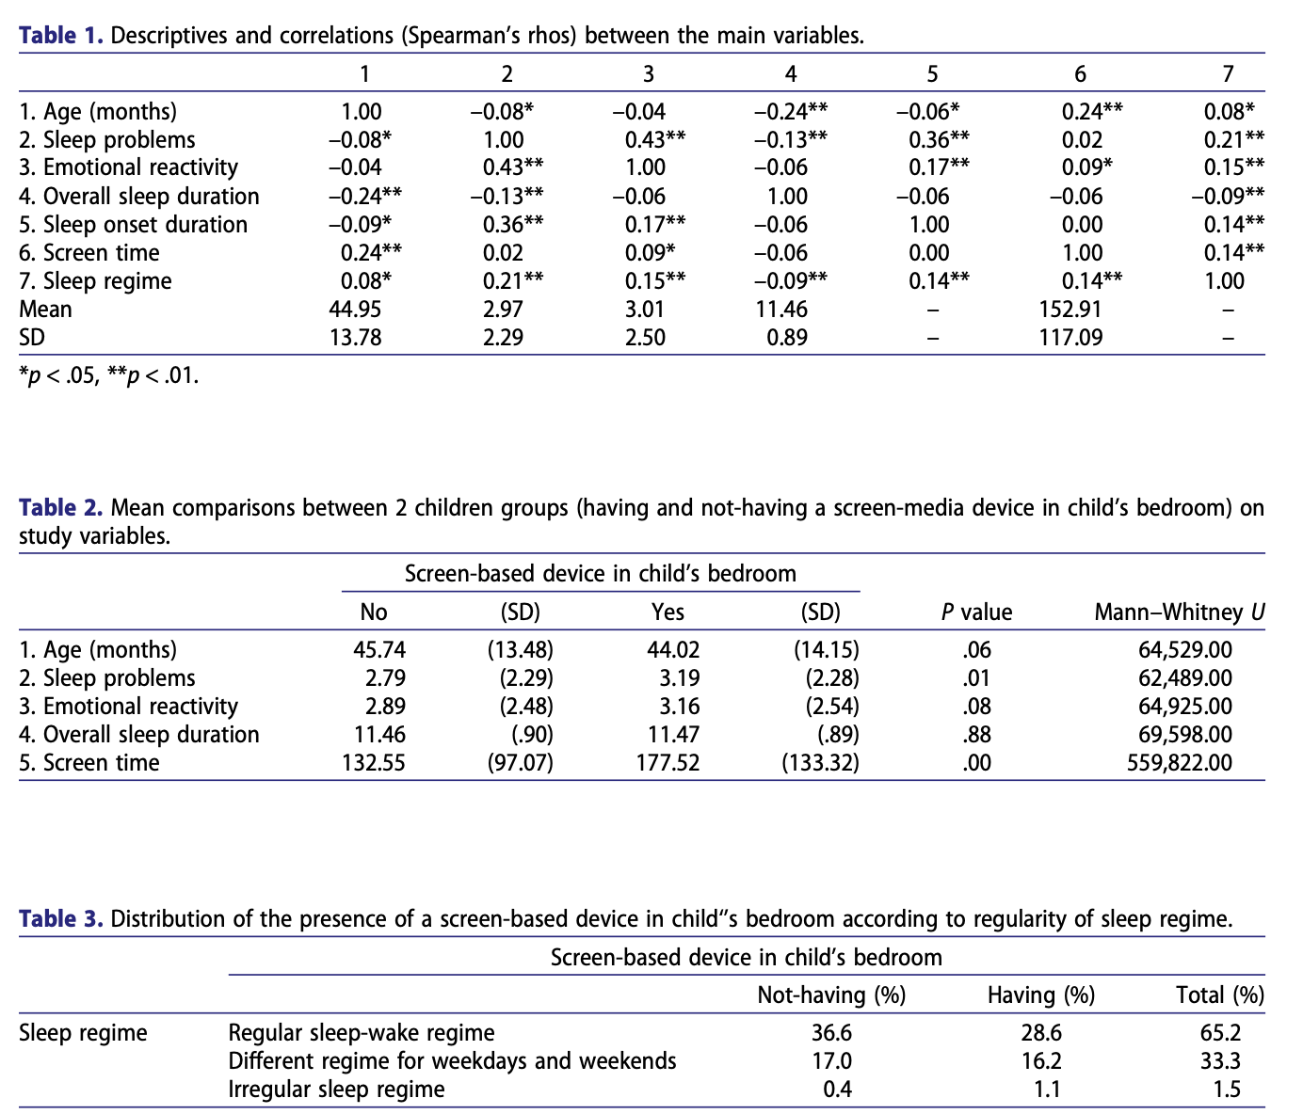

Discussion

Findings
All findings of the studies done have allowed me to answer the questions guiding my research. All studies have shown a negative correlation between the variables being compared. This includes the relationship between screen time and cognitive development, language development, sleeping patterns, and emotional development. Preschool students are negatively impacted by high amounts of screen time but show no negative effects when screen time is regulated.
Conclusions
Based on the analysis done, I conclude that high amounts of screen time have a negative effect on development and learning. Preschoolers should only be exposed to the recommended screen time based on the health regulations. Additionally, students who co-share screen time with parents might minimize the negative effects.
Implications
The use of technology can come as a huge advantage. However, we must know how to use it wisely in order to benefit from it. This research will allow me to understand more in depth the effects of technology on development and learning. This information will help me explain to students and parents the negative effects that screen time can play in their lives. It will also help me guide students and parents on what an appropriate amount of screen time can be and how to use technology wisely.

Limitations
This literature review has possible limitations. The limitations include the research questions that were used to guide my research. Having different or less research questions might have allowed me to find different relationships involving the variables. Another limitation could be the articles that were chosen to answer the research questions. If time allowed, I could have used multiple articles that aimed to answer the research questions. Lastly, conducting the research myself could have allowed me to see more specific population sample that relates to me. These are a few limitations that could be considered for future literature reviews.

References

Bailey, D. B. (2002a). Are critical periods critical for early childhood education?: The role of timing in early childhood pedagogy. Early Childhood Research Quarterly, 17(3), 281-294. doi:10.1016/S0885-2006(02)00165-5
Baukienė, E., Jusienė, R., Praninskienė, R., & Lisauskienė, L. (2021). The role of emotional reactivity in a relation between sleep problems and the use of screen-based media among toddlers and pre-schoolers. Early Child Development and Care, 192(9), 1402–1412. https://doi.org/10.1080/03004430.2021.1885392
Cerniglia, L., Cimino, S., & Ammaniti, M. (2020). What are the effects of screen time on Emotion Regulation and academic achievements? A three-wave longitudinal study on children from 4 to 8 years of age. Journal of Early Childhood Research, 19(2), 145–160. https://doi.org/10.1177/1476718x20969846
Cowan, N. (2013). Working memory underpins cognitive development, learning, and Education. Educational Psychology Review, 26(2), 197–223. https://doi.org/10.1007/s10648-013-9246-y
Mustonen, R., Torppa, R., & Stolt, S. (2022). Screen time of preschool-aged children and their mothers, and children’s language development. Children, 9(10), 1577. https://doi.org/10.3390/children9101577

YouTube. (2011, October 2). Diane Ravitch defends teachers and public education. YouTube. https://www.youtube.com/watch?v=IAivikFLJvU
Zhang, Z., Adamo, K. B., Ogden, N., Goldfield, G. S., Okely, A. D., Kuzik, N., Crozier, M., Hunter, S., Predy, M., & Carson, V. (2021). Associations between screen time and cognitive development in preschoolers. Pediatrics &amp; Child Health, 27(2), 105–110. https://doi.org/10.1093/pch/pxab067

