Rubi Perez
University of Texas Rio Grande Valley
EDCI 6302-02
Professor Noushin Nouri
August 14, 2023

Topic- Physical Properties of Matter
Grade level- 5th Grade.
Introduction
This paper will discuss a very important topic for 5th grade science: Physical Properties of Matter. This topic has many subtopics within. These subtopics include mass, magnetism, physical state, relative density, solubility, and conductivity. It is important for students to master this unit because it sets a foundation for many topics learned in science classrooms for 6th grade and beyond. Below is the concept map of all the concepts addressed within the unit. In addition, you will find common misconceptions gathered from years of experience teaching 5th grade science. Additionally, you will find best instructional practices and theories tied to teaching this unit. Lastly, you will find 2 lesson plans that show the incorporation of different practices and theories when teaching two subtopics: density and states of matter.
Concept map
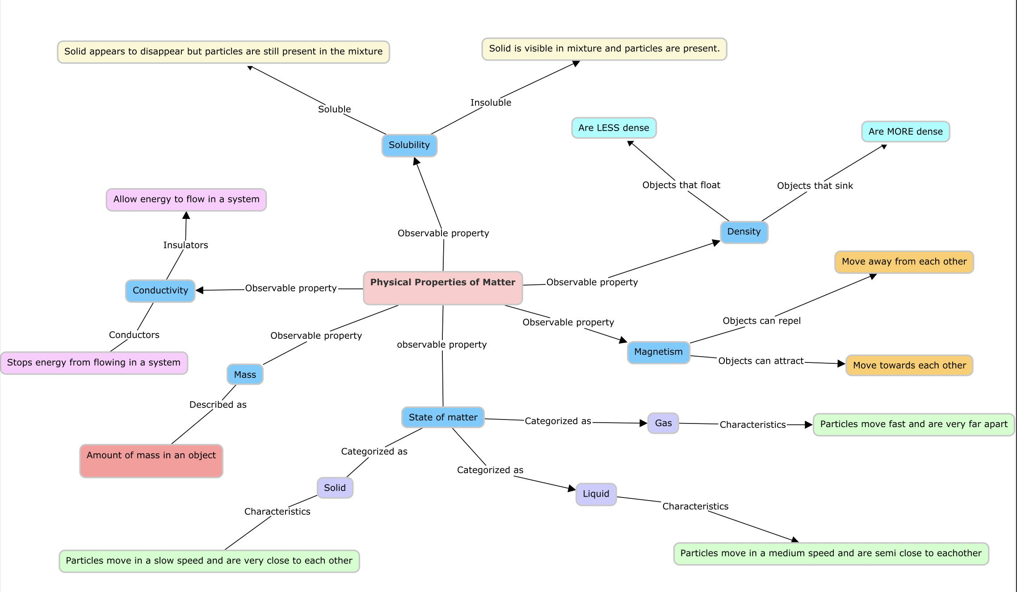

Misconceptions about topic
The misconceptions mentioned are those that I have seen while teaching 5th grade science.
Misconceptions:
- Solubility- when a solid dissolves in water, the solid is no longer present and impossible to separate.
Questions asked: What happens to the solid (sugar, salt, Kool aid) when it is dissolved in the water? Since we can no longer see the solid particles, does this mean that the solid disappeared? What will happen to the mass of the solution? Will the mass be less now that the solid is no longer visible? Once a solid is dissolved, will I ever be able to separate the solid and liquid again? What will happen if I boil a mixture of x (solid) and x(liquid?)
- Density- Big objects always sink and small objects always float.
Questions asked: Why do you think these items (small/big) float/sink? Does the size of the object affect if an object sinks or floats? Why do you think oil floats on water? What happens when we compare density of only liquids, does the size of the material really affect the density?
The following misconceptions have been common when teaching physical properties of matter. I believe it is because they cannot physically see the particles of different states of matter.
- States of Matter- Gases have no particles because they are invisible.
Questions asked: What are some examples of gases that you know? How can you describe a gas? What do you think the particles for a gas look like? Do they move?

- States of Matter- Particles in a solid do not move.
Questions asked: Since we know that a solid can keep their shape, how do you think the particles of a solid behave? How are the particles of a solid/liquid/gas different?

- States of Matter- Mass and size of particles change as state of matter changes. (There are more/less particles present, the particles get bigger/smaller.)
Questions asked: What happens to the particles of matter when they are melting/freezing/evaporating? If I melt an ice cube(solid) and it turns into water (liquid) do I have less particles now that it melted? If I boil water, will I have less steam than water? What if I can’t see it? Do the particles disappear when they change state of matter?

Best instructional strategies and theories for teaching this concept-
The Physical Properties of Matter topic can be a complex topic for 5th grade students to master. However, there are various instructional strategies and theories that can help teach this topic. The instructional practices that help teach and learn this topic include understanding the nature of science and process skills, constructivism and sociocultural theory, and the Model Based Science Teaching (MBST.) Following these instructional strategies and theories can help guide students towards mastery.
It is crucial for teachers to understand how students develop their own views of scientific knowledge. These views start to form at the beginning of the lesson in which information is presented to them. Since matter is a phenomenon that students cannot experience directly, it is important for students to relate to the information given. This inquiry-based method allows for students to explore information before teachers explain the concept. Inquiry focuses more on the development of the scientific process skills (Gilbert, 2011.) More specifically, in guided inquiry, the teacher facilitates thinking as students are introduced to a new phenomenon or problem. An example is provided in lesson plan 1 where students engage in a discussion about how to separate different ingredients that include water, Kool-Aid, and sand. The idea is for students to engage in the basic science process skills of observing, inferring, classifying, predicting, and communicating in order to understand different aspects of solubility. A recent study done by the University of Michigan-Dearborn also shows even teachers who participate in inquiry-based lessons during their training can effectively transfer these skills to students who participate in scientific inquiry. Luera, Mjoyer, Everett (2005) explain that “since the students in the inquiry classes experienced those standards many times throughout the course(s), they were able to demonstrate their understanding of inquiry on that section of the MEAP.” Similarly, teachers should push students to engage in inquiry-based learning that allows them to explore information, create their own views of scientific knowledge, and demonstrate basic and integrated process skills.
For students to be successful at mastering scientific knowledge, it is extremely beneficial to follow a constructivist method of teaching and a social cultural approach to learning. The constructive method of teaching allows for students to participate in a non-authoritarian approach that pushes them to construct their own ideas of information instead of being directly taught by a teacher. The social cultural approach pushes students to learn through interactions with others. Through constructivism, students participate in discussions to explain their own ideas about scientific knowledge while teachers act as facilitators. An example of the constructivism method could be found in lesson 2 while discussing the different states of matter. In this lesson, students actively participate in class discussions since the beginning of the lesson in the engagement part. Following discussion in the engagement part, students continue to explore information in a group setting then explain their findings to their classmates. These discussions can also serve as inform assessments that teachers can use to measure the level of understanding for some students. Lastly students elaborate their understanding of scientific knowledge by engaging in more classroom discussions. A recent study claims that students really benefit from group investigation. Students were interviewed and expressed that they experienced conceptual contradictions that were cleared up by participating in class discussions (Zorlu, Sezek, 2019.) Furthermore, students’ greatly benefit when engaged in group investigation and discussion as followed in constructivism.
Lastly, learning the physical properties of matter through Model Based Science Teaching (MBST) allows students to acquire more scientific understanding of the concepts. MBST focuses on the idea of creating models to understand scientific information. First, students create their own “mental models” which are their interpretation of information. These mental models allow for information to start getting organized in order to understand bigger concepts. Gilbert (2011) mentions in Chapter 4 the MBST framework that focuses on the problem, discovery, concept, and application. This allows for students to have a specific way to organize information since the beginning of the lesson. In terms of physical properties of matter, it is important for students to explore information before being given specific concepts that may confuse students. As mentioned before, matter may be difficult for students to understand because it is not something that students can see or manipulate with their own hands. Creating models for matter can really help the students understand the different properties and how they work. In both lessons provided, it has been a focus to give the students the space to create their own interpretations of information. This includes writing down their thoughts, drawing examples of particles of matter, and even acting out how matter behaves. These models allow for students to have a better understanding and organizing scientific concepts tied with the physical properties of matter.
In conclusion, there are many instructional strategies that can facilitate when teaching the physical properties of matter. These instructional strategies mainly follow an inquiry based approach that focuses on the use of models and sociocultural approach to learning.

Lesson plan 1- Density
Teacher: Rubi Perez
Subject / grade level: 5th Grade Science
Materials:
- Beakers
- Hot plate
- Spoons
- Sugar
- Thermometers
- Water
- Worksheets/pencils
Texas Essential Knowledge and Skills Selected:
5.5(A) classify matter based on measurable, testable, and observable physical properties, including mass, magnetism, physical state (solid, liquid, and gas), relative density (sinking and floating using water as a reference point), solubility in water, and the ability to conduct or insulate thermal energy or electric energy.
Lesson objective(s):
- Students should be able to describe characteristics of matter that can dissolve in water.
- Students should be able to understand the term solubility.
- Students should be able to identify what solids are soluble and insoluble.
- Students should be able to explain how water temperature affects solubility.

Differentiation strategies to meet diverse learner needs:
- Post anchor charts with vocabulary and visuals for solubility
- Incorporating visuals into worksheets
- Pairing academically high and low students
- Pairing ELLs with students who speak both languages.
- Translating work for ELLs

ENGAGEMENT
- Teacher will scaffold previously learned knowledge about describing different physical properties.
- Teacher will display a beaker filled with water, a bowl with Kool-Aid (pink powder), and a separate bowl of sand.
- Teacher will prompt students to use THINK-PAIR-SHARE to describe what they think would happen to the different materials when they are mixed. Teacher should allow for students to think and write down, then share with a partner close to them, then share in a whole group discussion.
- Once students are sharing in a whole group discussion the teacher will prompt students with questions to allow students to start thinking about the objective linked to solubility.
- What will happen to the color of the water, pink powder, and sand?
- How much of the items will be present once they are mixed?
- What properties do you think will change/ stay the same?
- Why do you think that will happen?
- “Keep this in mind when we are conducting today’s experiment.”

Example of student worksheet below:

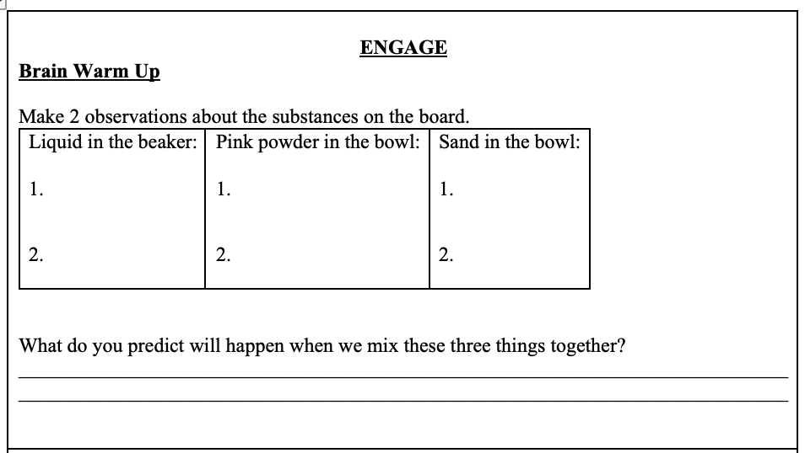

EXPLORATION
- Teachers will allow students to compare two beakers with different substances. Beaker 1 will have room temperature water with sugar. Beaker 2 will have hot water with sugar.
- Teacher will push students to make observations about the substances and draw them.
- Teacher will facilitate discussion with different groups by circulating and asking questions:
- How are properties different with beaker 1 and beaker 2? How do they look different?
- Why do you think they look different?
- What is causing the substance to look so different in beaker 2?
- Why do you think the water is making a change in the solution?
- What do you call it when you can no longer see the sugar in the water?
- Is the sugar really gone? Did it magically disappear?
Example of student worksheet below:
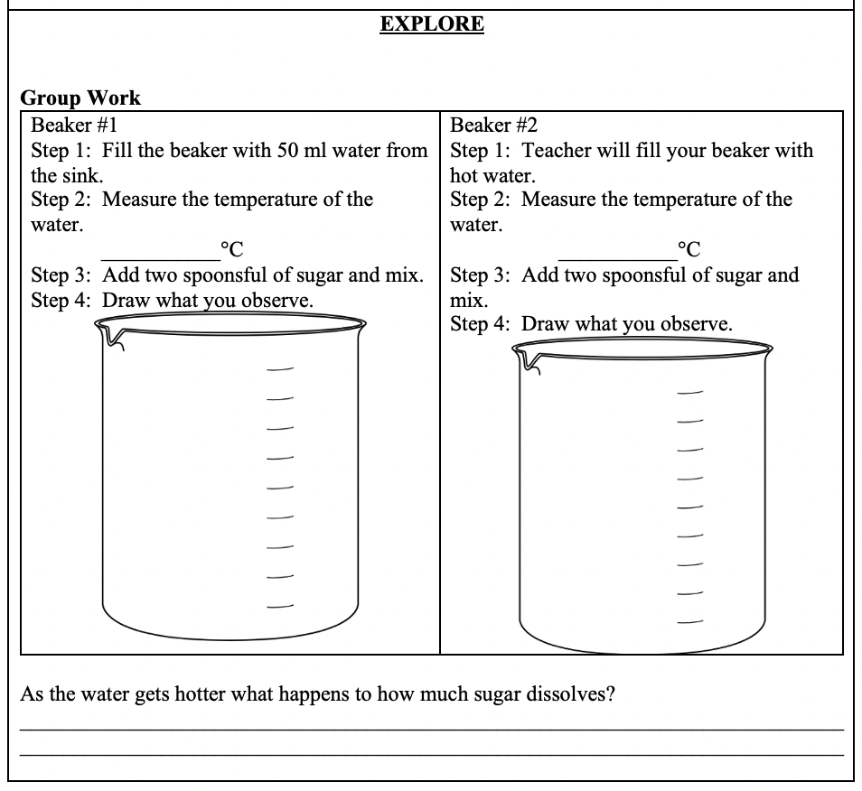
EXPLANATION
- Teacher will facilitate a whole group discussion that will allow students to share their findings to the lab in the exploration part.
- Students should be able to stamp:
- Sugar is soluble in water,
- sugar is still present in the water but is not visible,
- hot water allows for sugar to dissolve faster,
- particles move faster with heat present.
- Teacher will prompt students to draw and write down the objectives being stamped.
- Teacher will prompt students to share what other items are soluble and insoluble by completing the chart in their paper as a class.
Example of student worksheet below:
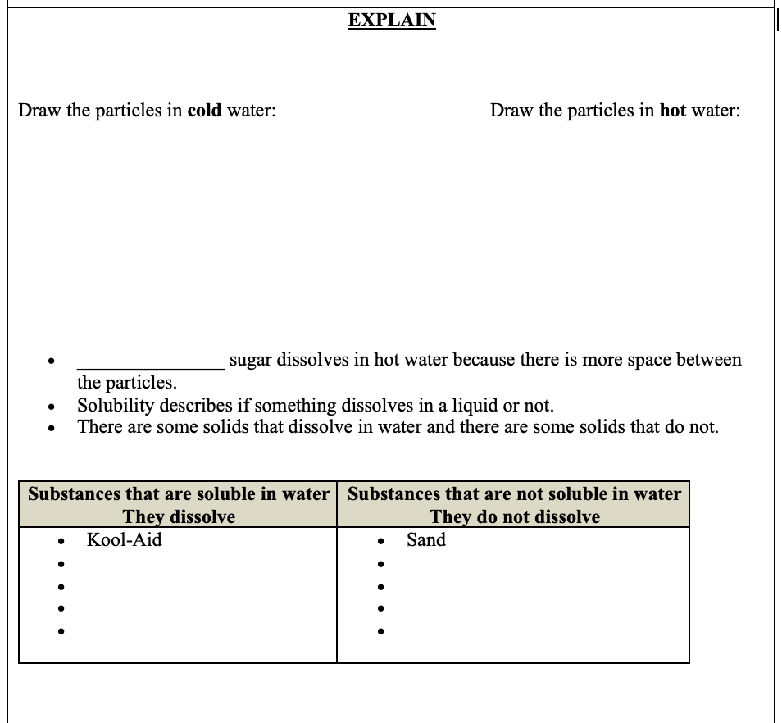
ELABORATION
- Students will engage in answering solubility questions independently for a couple of minutes then sharing their thoughts with a partner. This will allow students to focus on their understanding based on the engagement, exploration, and explanation portions of the lessons.
- Once students engage in independent work and group discussion teacher will stamp what students should be able to identify and address major misconceptions seen.
- Students should be able to identify different items that dissolve and don’t dissolve in liquids.
- Students should be able to identify that soluble means to dissolve and insoluble means to not dissolve.
- Students should be able to identify that adding heat to a substance speeds up the process of dissolving.
Example of student worksheet below:
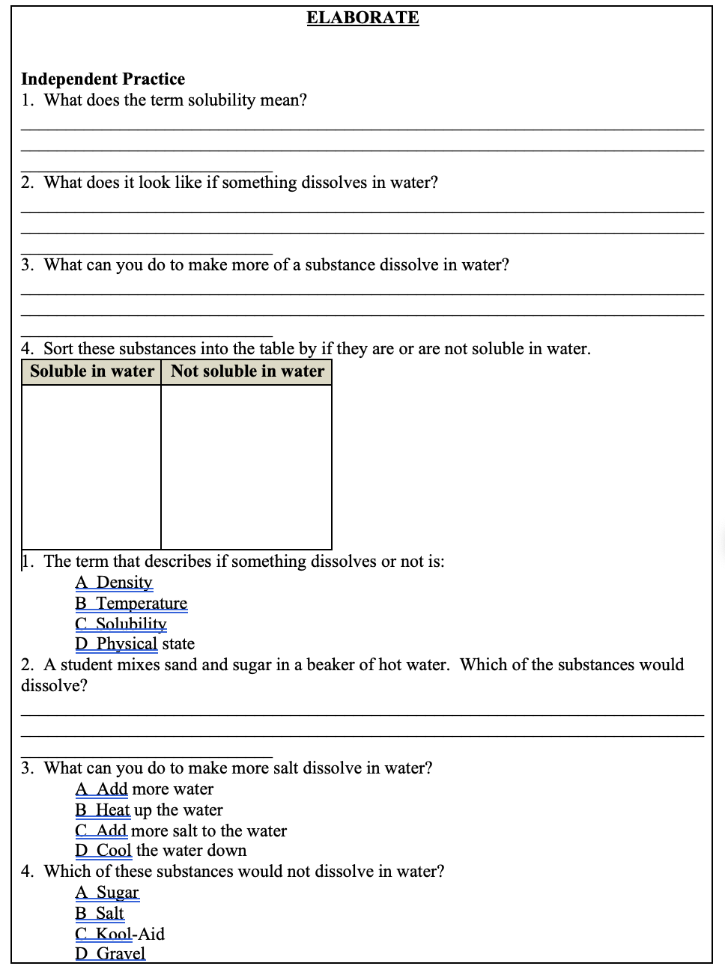

CONTINUATION ELABORATION
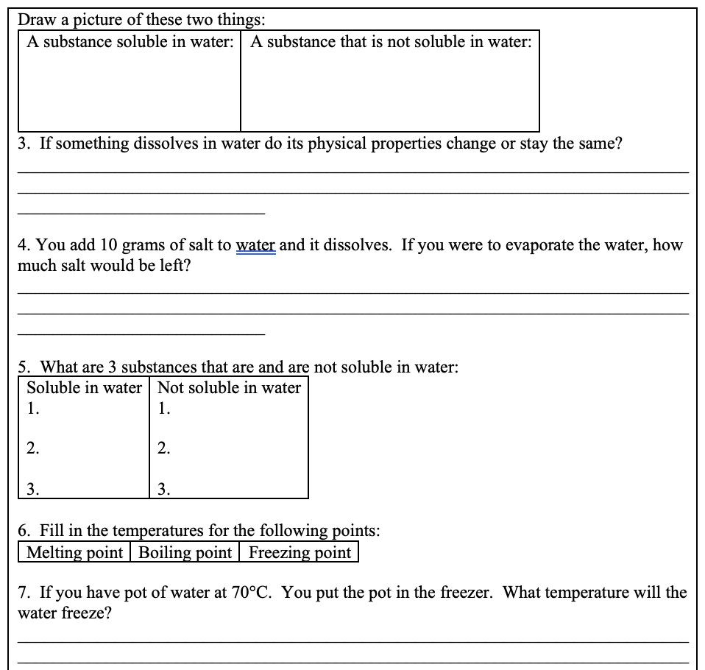

EVALUATION
- Students will be assessed to see if they mastered the objective by what they share during the exploration, explanation, and elaboration class discussions.
- Students will also be assessed via an exit ticket that they will conduct independently.
- If time allows, teacher will address the most missed question and address misconceptions after the exit ticket.
Example of student worksheet below:
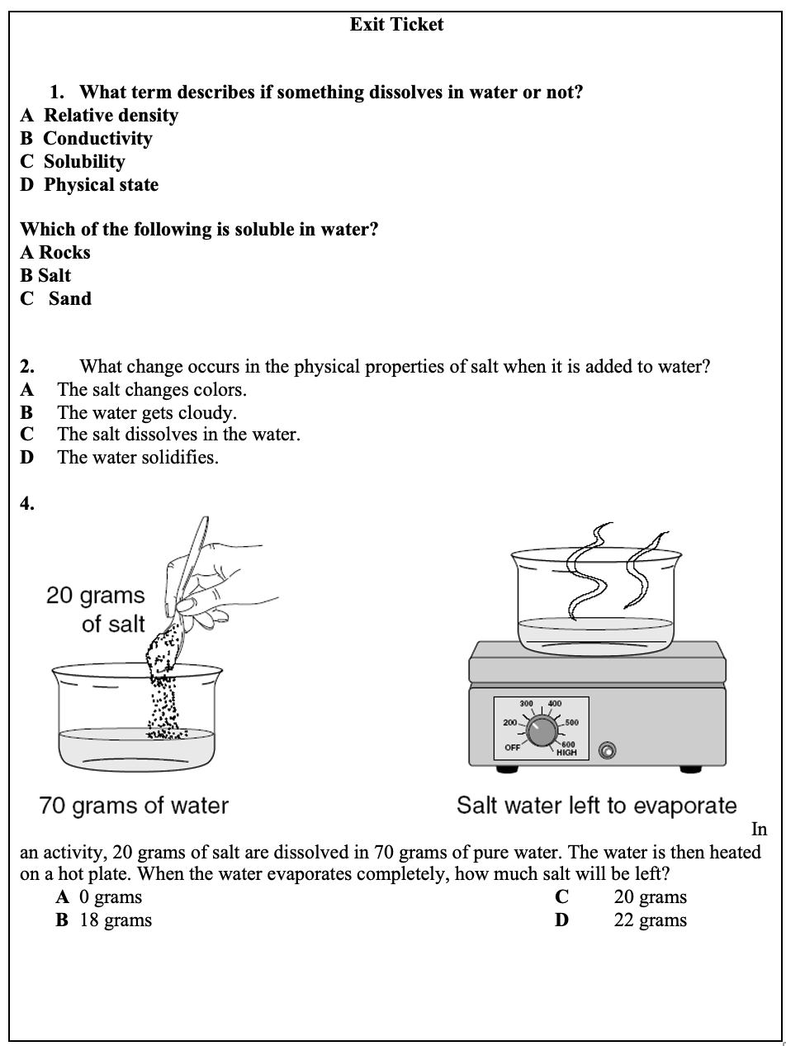

Lesson Plan 2- States of Matter
Physical Properties of Matter- States of Matter
Introduction of the Topic- Teacher will let students know that they will be investigating how the different particles of matter act in different states. Teacher will engage students in a version of “Simon says” in which students will have to act out how the particles move for a solid, liquid, or gas state. Students should be able to start creating mental models of what particles for the different states of matter look like and how they behave while in different states.
Objectives-
- Students will be able to define and identify the particle arrangement, speed and relative temperature of solids, liquids and gasses.
- Students will be able to identify examples of solid, liquids and gasses.
General Approach- The lesson approach is intended to be a constructivist approach that will allow students to explore hands on activities and engage in discussions. Teachers will facilitate exploration, and class discussions while students guide their thinking as they develop their mental models for the concepts of states of matter.
Procedure/Method- Students will explore three different stations and answer questions to guide their thinking. The first station will have a balloon that is filled with gas. The second station will have a soda that will have representation of a solid, liquid, and a gas. The last station will have a hot plate with a beaker that has boiling water. As students are making observations in the different stations, the teacher will walk around and ask questions about the different states of matter demonstrated in each station. The students will have an opportunity to write down their thoughts and draw their interpretation of particles in the different stations.
Example below:
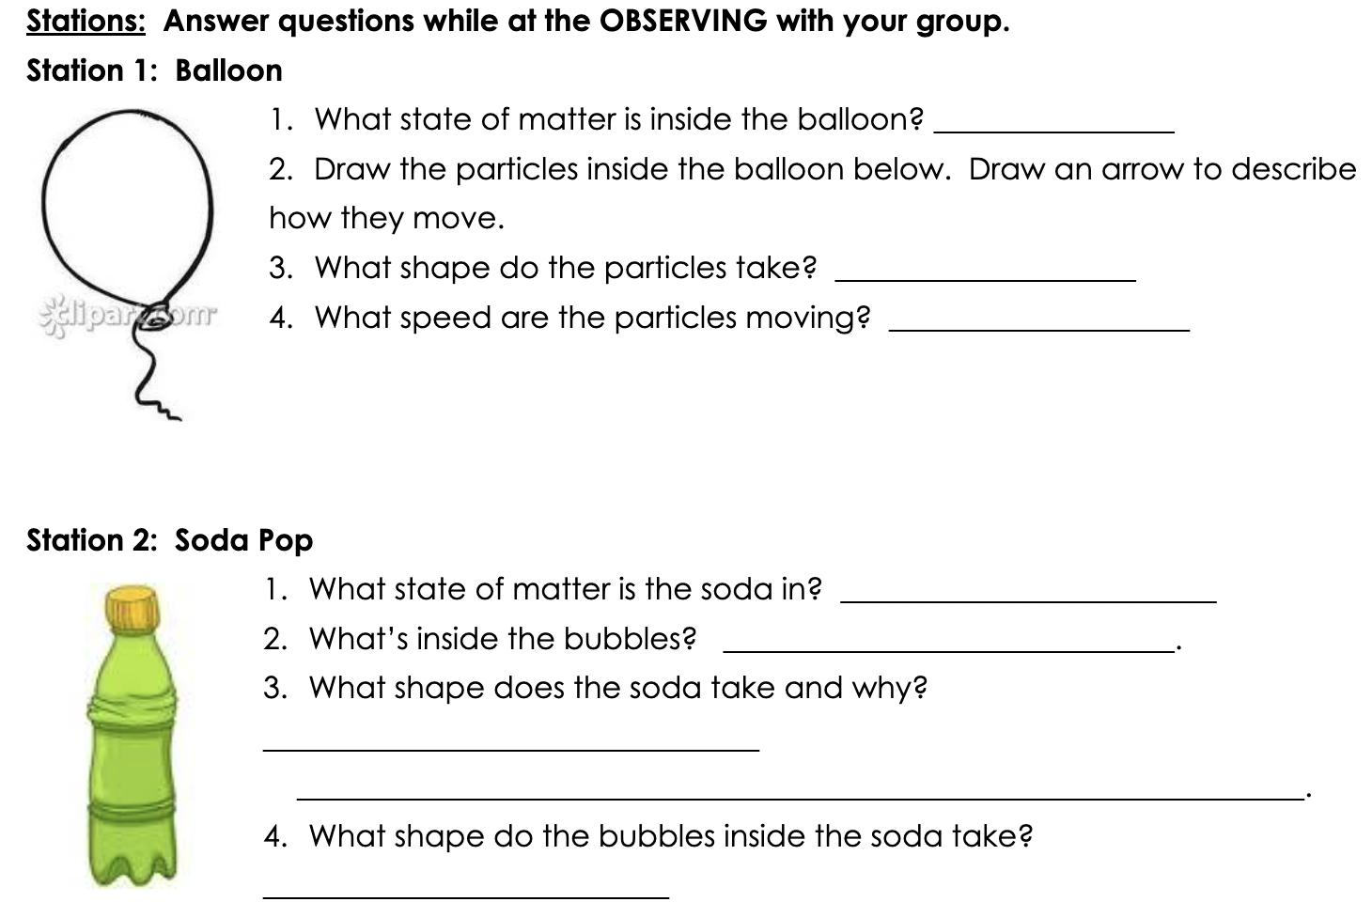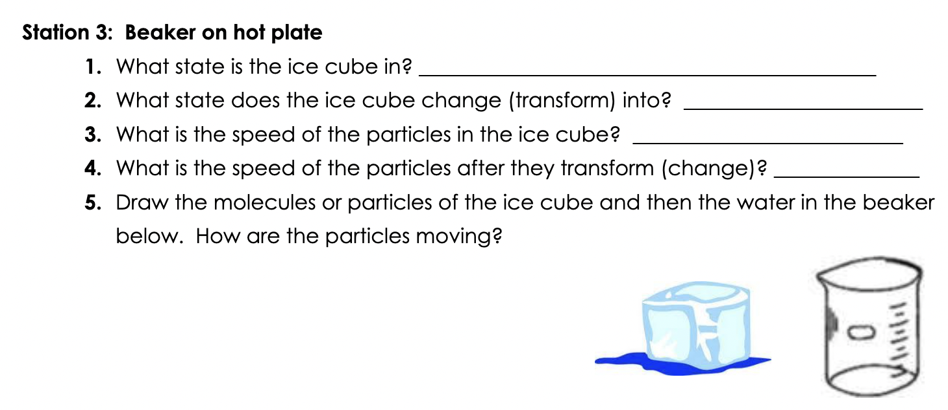

Student Age/Demographics-
  - 5th grade students
  - Age:10-11
  - Latino/White/African American
  - ELL’s
  - Some academic disabilities
Lesson Design-
Students engage in States of matter “simon says” (5 minutes)
Students explore different stations with examples of states of matter. (15 minutes)
Students explain mental models created during exploration by discussing with peers.
Teachers should be prepared with premade questions to facilitate discussion. (10 minutes)
Students elaborate by answering questions about states of matter independently then sharing thoughts with peers. (20 minutes) Examples below:
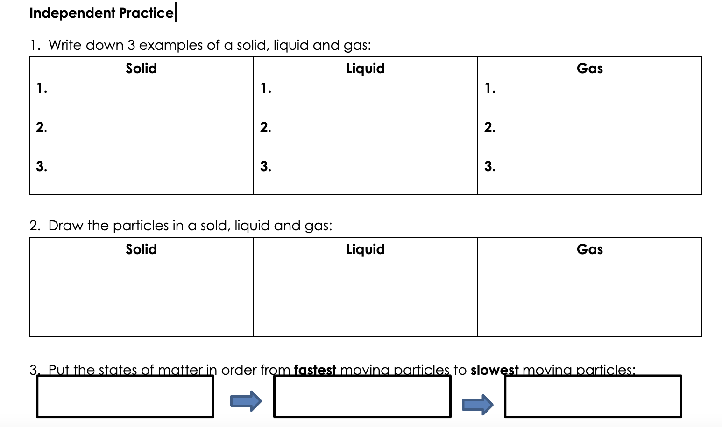 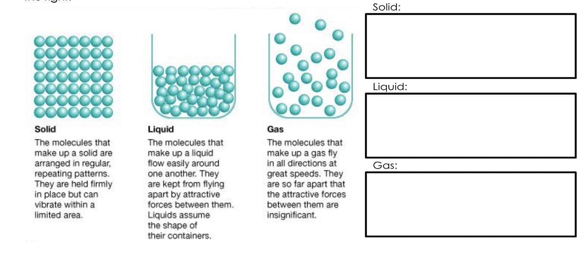
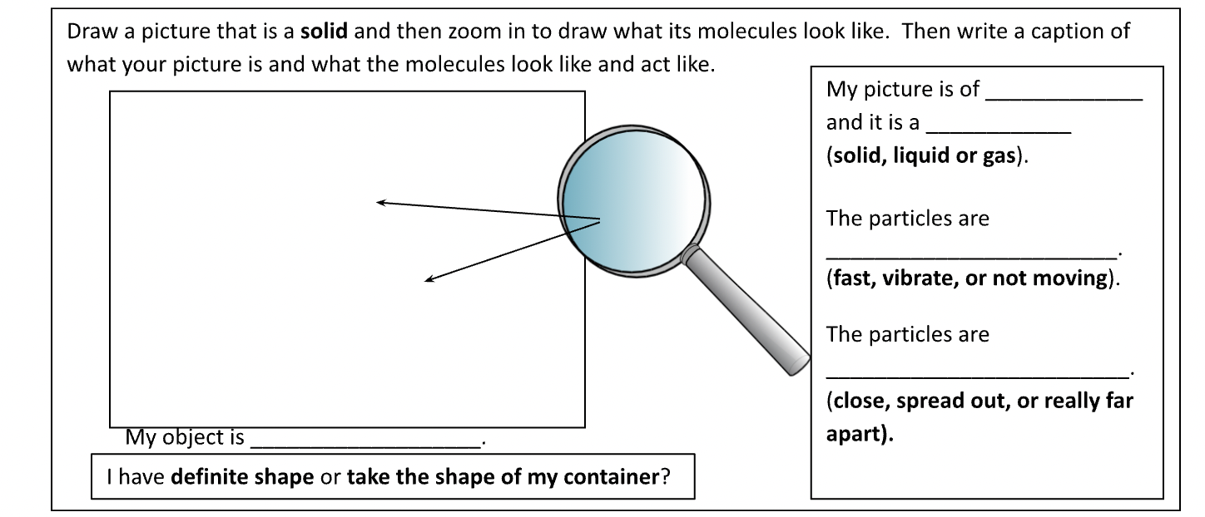
Students are formally evaluated with an exit ticket (10 minutes)

Assessment Summary/Conclusion- Students will be informally assessed by answering discussion questions with their peers and in whole class setting. Students will be formally assessed by completing an exit ticket.
Example below:
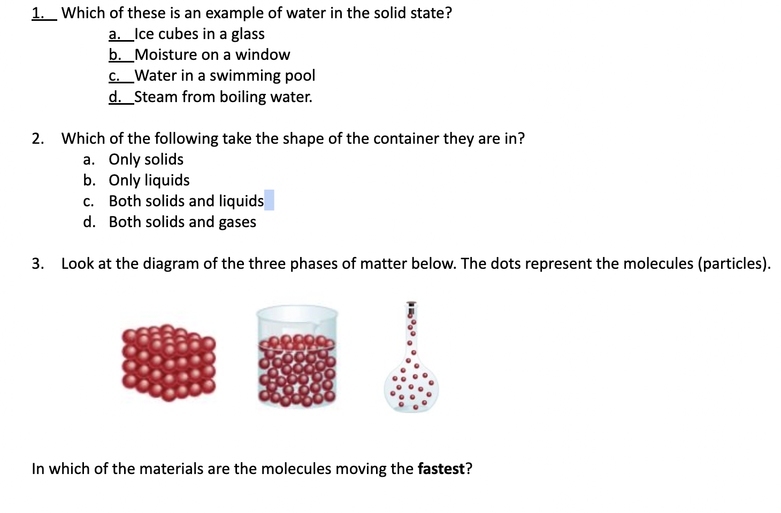
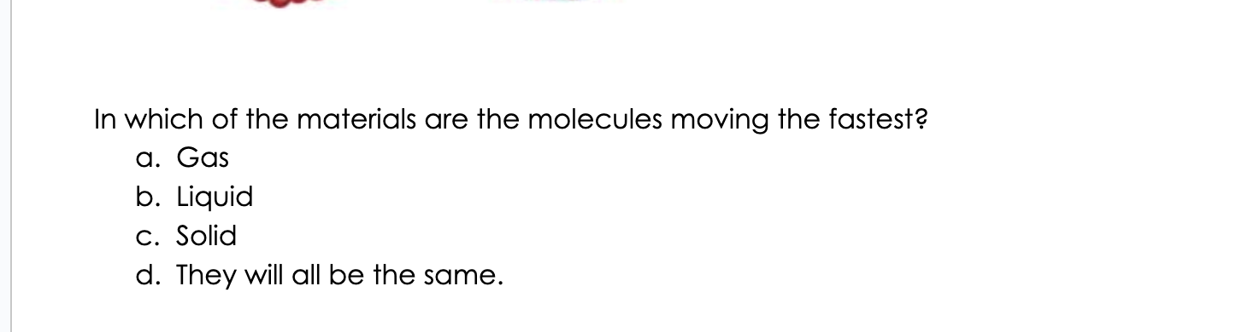
Expected Results- Students should be able to identify that:
- A solid is an object that has a definite (fixed) shape and molecules that are very tightly packed and move very slow.
- A liquid is a substance that changes shape to fit the container it is in, and particles move medium speed.
- A gas has no definite shape or volume, and its molecules are loosely packed, and particles move very fast.
Within the expected results students should be able to explain their mental model of how particles of different states of matter behave. Students have the autonomy to create mental models by acting out, explaining verbally to peers, drawing, or writing their understanding of the concept.

Handling Outliers- Common Misconceptions:
- Gases have no particles because they are invisible. Gases have particles that move very fast and cause more heat.
- Particles in a solid do not move. Particles are tight together but do have some space to move.
- Mass and size of particles change as state of matter changes. (There are more/less particles present, the particles get bigger/smaller.) Particles never change their size or disappear or appear. They only behave/move differently in the different states.
Reflecting on Effectiveness- Interpreting data about states of matter might be difficult for students to understand since matter is a microscopic thing that students cannot see or manipulate with their hands. Student should have the autonomy to show their understanding of particles for different states of matter. It is important for the teacher to push students to share their interpretation of states of matter and guide them through misconceptions. Students can share their mental models in various ways that can respect and celebrate their abilities.

References
Zorlu, Y. & Sezek, F. (2019). Investigation of the Effects of Group Research Method of
Applying Modeling Based Teaching Method in the Particle Structure and Properties of Matter Unit on Constructivist Learning . Sakarya University Journal of Education , 9 (3) , 455-475 . DOI: 10.19126/suje.481295
Deborah L. Hanuscin, Dante Cisterna & Kelsey Lipsitz (2018) Elementary Teachers’
Pedagogical Content Knowledge for Teaching Structure and Properties of Matter, Journal of Science Teacher Education, 29:8, 665-692,DOI: 10.1080/1046560X.2018.1488486
Liu, X. and Lesniak, K.M. (2005), Students' progression of understanding the matter concept
from elementary to high school. Sci. Ed., 89: 433-450. https://doi.org/10.1002/sce.20056

Journal of Elementary Science Education, Vol. 17. No. 1 (Spring 2005), pp. 12-25. Department
of Curriculum and Instruction, College of Education and Human Services, Western Illinois University.
Gilbert, S. W. (2011). Models-based science teaching. Arlington, VA: NSTA Press.
ISBN 978-1-936137-23-7, Read Chapter 3 in Gilbert (2011), pp. 30-49.

