Eliciting Student Thinking

Rubi Perez

The University of Texas Rio Grande Valley

EDCI- 6351

Dr. Victor Vizcaino

August 5, 2020

The students who were assigned the mathematical tasks were two 7th grade students who I tutored through out the summer. The students were asked to show their work and final answer for the task in Figure 1. In addition to the task, I asked students to explain what it means to find the area of the top surface of the desk. Below the task example you will find the procedural fluency, conceptual understanding, and problem solving techniques that were observed during the process.

Figure 1.

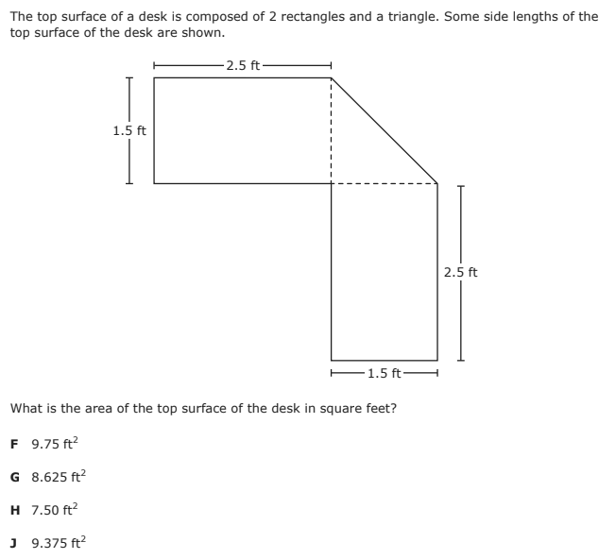

**Procedural Fluency**

*Student 1*

Overall, student 1 had very good procedural fluency. The student was able to identify that there were two different shapes whose areas were determined differently. The student was able to compute that the area of the rectangles was determined by multiplying the length by the width of the given shape. The student did not struggle to find this equation as they had it memorized. Similarly, the student was able to identify that the formula used for the rectangle was not the same formula used for the triangle. The student was successful at using their formula chart as a resource to determine what formula to use to identify the area of the triangle. Figure 2 shows the students procedural fluency. Student 1 receives a score of 4 for their procedural fluency and their ability to use formulas to complete the given task.

Figure 2. Figure 3.

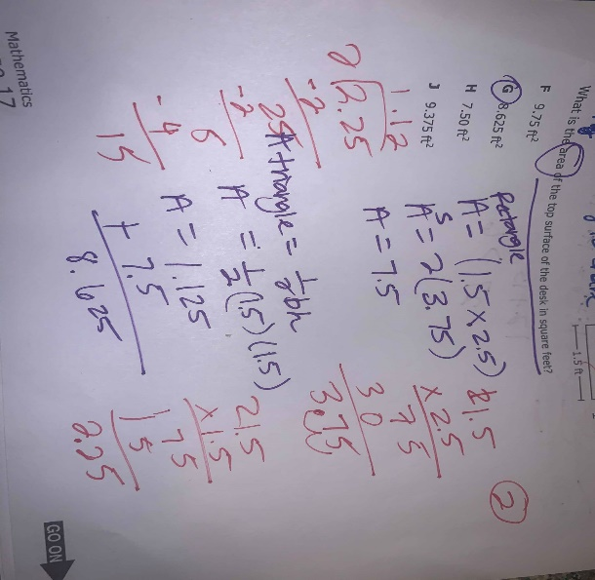 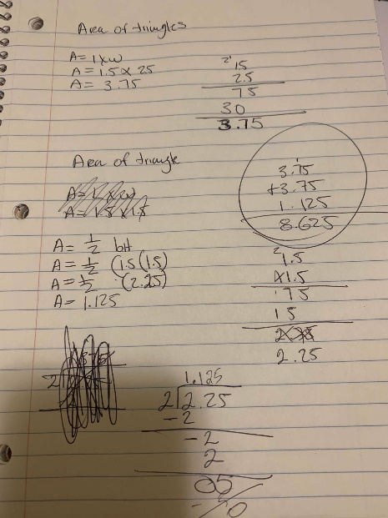

*Student 2*

Contrary to student 1, student 2 had some trouble identifying the correct formulas that were needed to be used to complete the task. Student 2 was able to identify that there were two different shapes that contributed to the overall area, but failed to know how to find the area for the separate figures. The student was able to determine the area of the rectangle by multiplying the length and the width. However, when it came time to determine the area of the triangle, the student wanted to use the same formula used to determine the area of the rectangles. I had to intervene and ask the student if the formula used before could still be applied to finding the area of the triangle. The student was then able to realize their mistake and use the formula sheet to find the area of the triangle. Figure 3 shows the student’s procedural fluency. Student 2 receives a score of 3 for their initial misuse of formulas but their ability to fix their problem.

**Conceptual Understanding**

*Student 1*

Student 1 demonstrated his conceptual understanding of the problem by answering the second question that asked what it means to find the area of the top surface of the desk. The student had no difficulty explaining that the area of the desk described everything within the inside. He used his pencil to shade in the two rectangles and triangles that demonstrated the overall area. The student was then asked “why would it matter to find the area of the top of a desk?” To which the student responded “maybe it could tell us what can fit on top of the desk.” This answer told me that the student was able to make connections and explain how the task could help in the real world. Student 1 scored a 4 for conceptual understanding for their ability to explain their understanding of the concepts and associated procedures.

*Student 2*

Student 2 had a harder time demonstrating their conceptual understanding for the task given. The student was unable to explain what the area of an object tells us without my guidance. I continued to ask her if the area of the desk was everything that was inside the figures or was surrounding the figures. The student explained that the area of the figures was the section surrounding the dimensions of the desk. She showed me this by pointing to the figure with her pencil. I then explained that the section she was pointing at was the perimeter of the figure and that she was confusing the vocabulary that differentiated the area and the perimeter of the figure. After explaining this I asked why it would matter to find the area of the desk. She then explained “it would tell us how big the desk is.” Student 2 received a score of 2 in conceptual understanding for their inability to make connections between concepts and procedures.

**Problem Solving/Strategic Competency**

*Student 1*

Student 1 had great problem solving skills and strategic competency. As showed in Figure 2. The student was able to use and manipulate the formulas greatly. Once great example of this is when he was finding the area for both the rectangles. He knew that the area of one rectangle would be the same for the second rectangle therefore he added a step to the formula where he multiplied by 2. This gave us the total area for both rectangles. He was also able to do this when he used the formula for finding the area of the triangle and including one last step that added the area for the rectangles and the triangle to give us the overall area of the figure. The student was also able to demonstrate minor mathematical procedures that added to the overall answer and included multiplication and division of decimals. His overall strategy allows him to score a 4 for problem solving.

*Student 2*

Student 2 had an appropriate approach to solving the task given. As showed in Figure 3 student often had minor mistakes that would overall impact his final answer. The student was not able to manipulate formulas like student 1 but was still able to identify the procedures that had to be done to find the answer. Minor computational mistakes like multiplication, division, and addition of decimals would have made the students answer wrong. I intervened in several of the computational steps by asking the student to describe how they found the answer. The student was able to find mistakes and problem solve to the appropriate step needed to be taken. Although the final answer for the task was correct, Student 2 scored a 2 for problem solving and strategic competency that needed guidance.