Subject / grade level:
Math- 3rd Grade
Lesson objective(s):

- Find area and perimeter for various shapes.
Differentiation strategies to meet diverse learner needs:
- Post anchor charts with vocabulary and visuals.
- Incorporating visuals into worksheets.
- Pairing academically high and low students
- Pairing ELLs with students who speak both languages.
- Translating work for ELLs

ENGAGEMENT
“Mrs. Perez has a fun idea to make a bulletin board for spring. She wants the inside to be yellow using butcher paper, but she's not sure how much to buy. She also plans to put a string of flowers around the board. How can Mrs. Perez figure out how much paper she needs for the inside and how much flower string is needed for the outside?”

Students write down their thoughts then share out with students near them.
Teacher calls out students to share their thoughts but doesn’t share to revisit at the end of class.
Teacher then introduces vocabulary words area and perimeter.
Area is the space inside a shape. Perimeter is the distance around the shape.

EXPLORATION
Teacher: Pre-tape various shapes on the ground using the guidance of tile squares.
Students: Student will work in groups to find the area and perimeter for the corresponding shapes. Student will be given a ruler to measure using inches. Students will use sticky notes to represent the area of the shapes.
Teacher: Walk around while students are working and ask questions to guide thinking.
Questions:
What do the stickies represent?
What do you notice about the area of the shapes when using the stickies and the formula A=lxw?
How can you find the perimeter of a shape that has different lengths?
How can you find the perimeter of a shape in which you only know one or two sides?
How can you find the length of a side not given?
How is it easier to find the perimeter of a square given one side?

EXPLANATION
Teacher: Direct students back to their seats and asks for volunteers to share their findings and area and perimeter during the activity.
Teacher proceeds to model a problem
ELABORATION

Students: work on scavenger hunt around the class to work on problems for area and perimeter. Some of the questions can look like the ones below:

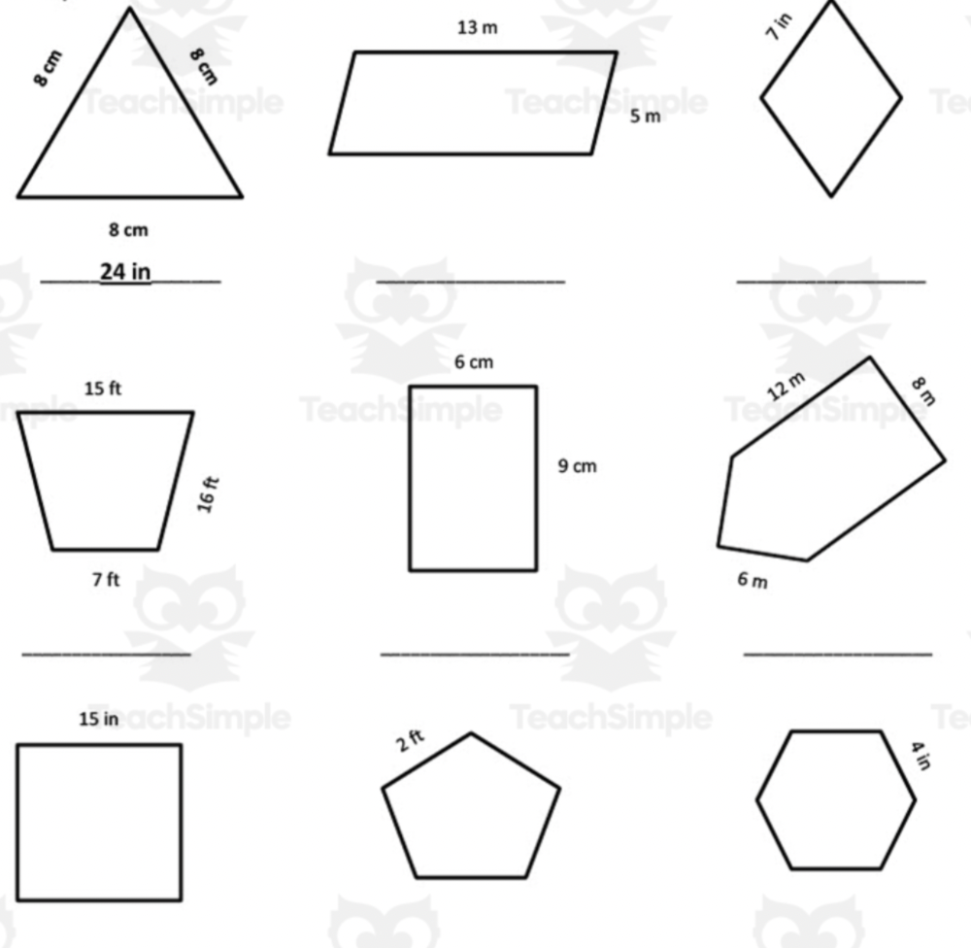
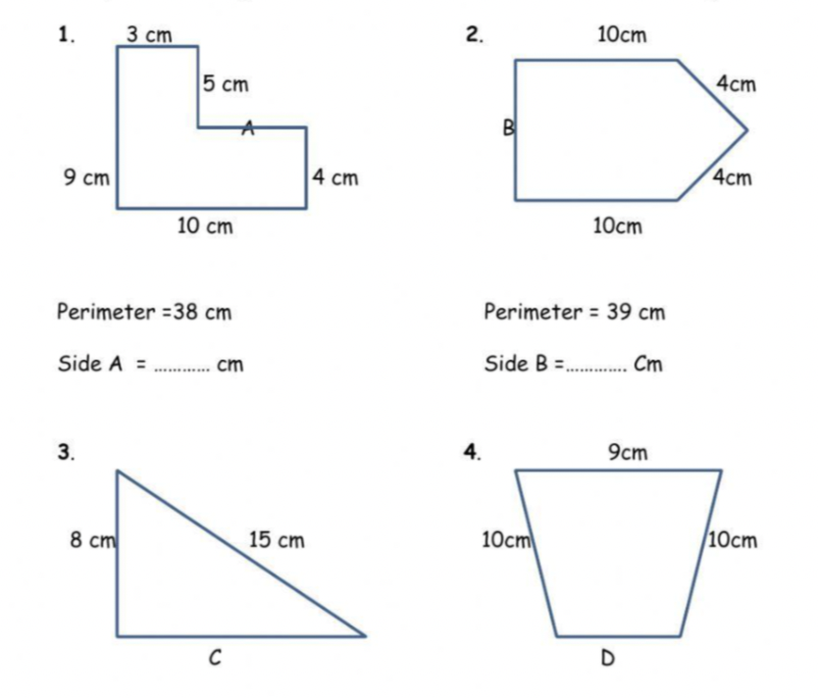
Teacher: Walk around and ask questions to guide thinking. Make note of most difficult questions for students to answer.
What do the stickies represent?
What do you notice about the area of the shapes when using the stickies and the formula A=lxw?
How can you find the perimeter of a shape that has different lengths?
How can you find the perimeter of a shape in which you only know one or two sides?
How can you find the length of a side not given?
How is it easier to find the perimeter of a square given one side?

Teacher: Go over the most challenging question based on observations. Ask students the engagement questions to see if they can apply the knowledge practiced during class.

EVALUATION
Students will take an exit ticket to show how they can find the area and perimeter for the following shapes:
